Repeat Open Application Test (ROAT) Patient Information Leaflet

What is a ROAT?
A ROAT is a way to check if a product is causing an allergic reaction on your skin. It involves applying the product to a small patch of healthy skin and watching for a reaction over a few days or weeks. It is often used if you want to see if a product is causing your skin problems or you are waiting for a patch test.

Which products can you test?
ROAT is only safe for products normally applied to small areas of healthy skin.
- Leave-on products: creams, moisturisers, sunscreens, perfumes
- Wash-off products: shampoos, body washes (applied and rinsed like normal use)

What products are NOT suitable for a ROAT?
Do not use products that could be unsafe or irritating, such as:
- Household cleaning products (bleach, detergents, oven cleaners)
- Strong acids or chemical peels (glycolic acid, salicylic acid, retinoids)
- Products that can cause systemic reactions (oral medications, injectables)

How to do a ROAT
- Choose a 2x2 cm area on your forearm
- Make sure the skin is healthy and free from eczema or rashes. Do not use steroid creams on the test area while doing ROAT – they can hide reactions.
- Mark the area with a skin-safe marker or tape to outline the patch. This helps you apply the product to the same spot each time
- Apply a thin layer of the product twice a day (morning and evening)
- Continue for 2 weeks (14 days)
- Keep a daily diary of the patch area and note any redness, itchiness, swelling or blistering

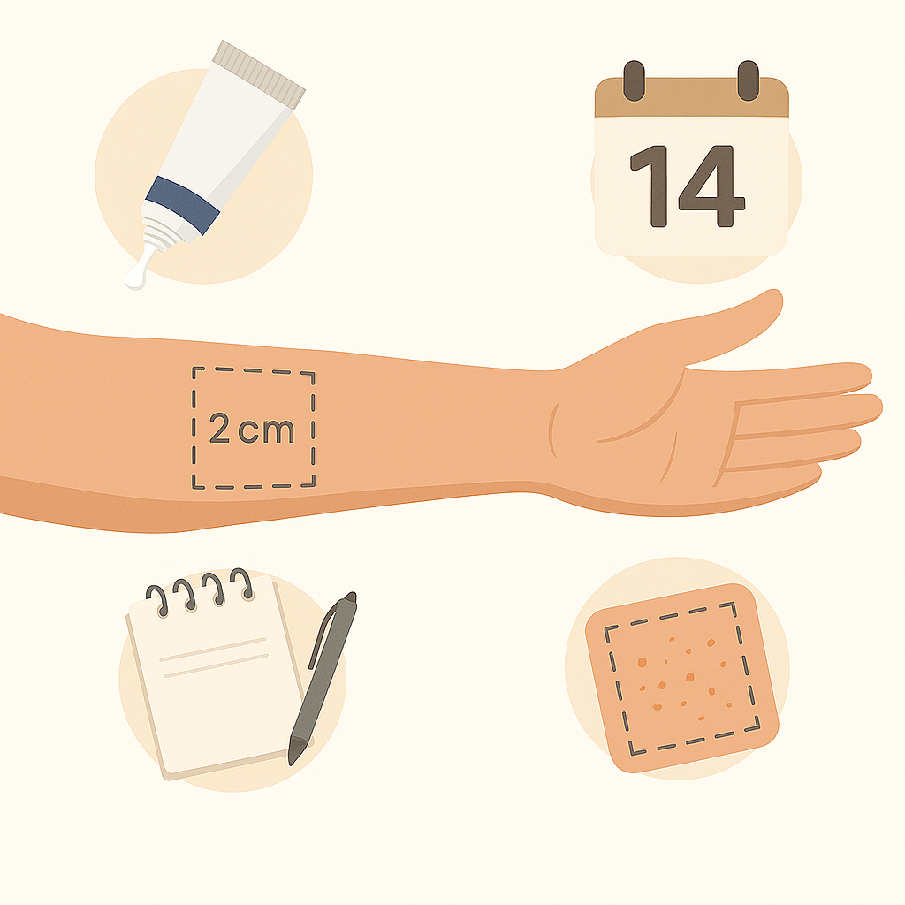
What do the results mean?
- No reaction → The product is unlikely to be causing your skin problem

- Reaction occurs:
- Stop using the product immediately
- Avoid applying it anywhere else
- Take photos of your reaction, product/s, and ingredients; seek advice if required/advised

Created: 2025 Updated: 2026

