
British Society of Cutaneous Allergy
BSCA
Patient information leaflets
Please scan the QR code below to find an information leaflet about your allergen

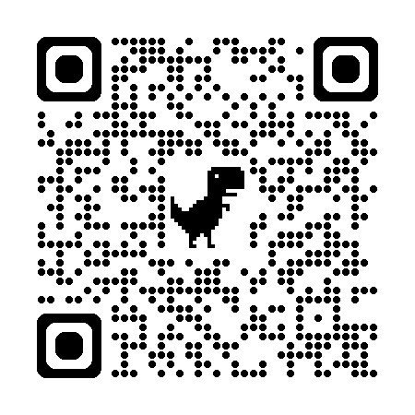
SCAN ME

Patient information leaflets are available for the following series – Standard, Medicament and Facial Series

