
Dear

Your patch tests indicate you have a contact allergy to the following allergen(s):

Your doctor will have reviewed relevant information about your allergen(s) with you.
Please do review the clinic letter that you will receive following your clinic consultation.
Please scan the QR code below to find an information leaflet about your allergen(s)
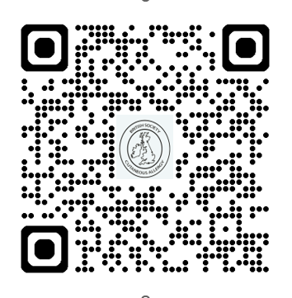

SCAN ME

Further information on ingredients in cosmetic products can be found at https://incidecoder.com

