CUTANEOUS ALLERGY UPDATE – HYBRID MEETING
29TH MARCH 2023

SPEAKERS BIOS

DR DEIRDRE BUCKLEY, FRCPI FRCP

Dr Deirdre Buckley is a Consultant Dermatologist working in Bath, UK.

She qualified in medicine at University College Cork (Ireland) in 1988 and trained as Senior Registrar in Dermatology at University College Hospital, London. She worked as Consultant Dermatologist at Great Western Hospital, Swindon, UK and at the Royal United Hospital, Bath, UK. She has a particular clinical and research interest in fragrance allergy. She chaired the Medicines Working Group of the British Association of Dermatologists 2013-2019 and was a member of the BAD Therapy and Guidelines Committee 2010-2021. She served as the President of the British Society for Cutaneous Allergy 2018-2021. In 2022 she was awarded the Bisset Hawkins Medal of the Royal College of Physicians for work during the previous 10 years in advancing public health.
Learning points
* To understand the increasing relevance of allergic contact dermatitis to (meth)acrylates
* To be aware of best practice in testing for (meth)acrylate allergy
* To improve awareness of how to advise those already sensitized

EMILY CARNE, Consultant Nurse, Immunodeficiency Centre for Wales

Emily Carne is the Consultant Nurse in Immunology & Allergy Service for Wales in Cardiff. She worked as the Lead clinical nurse specialist in the service since 2001. Emily has published on many different aspects of primary immunodeficiency and allergy, including improving quality of life, utilising home therapy and managing the burden of treatment. She is the author of the chapter ‘Care of the adult with an immunological condition’ in the core undergraduate nursing text book ‘Essentials of Nursing Adults’.

She has held committee positions on the board of the British Society of Immunology – Clinical Immunology & Allergy Section, UK Primary Immunodeficiency Network, International Nurse Group for Immune Deficiency, British Society for Allergy and Clinical Immunology and was chair of the Immunology and Allergy Nurses Group UK. She is the current chair of the Welsh Allergy Nursing Network, sits on the WG advisory group for Allergy services, the Medical Advisory Panel for Immune Deficiency UK and Immune Deficiency Patient Group Wales.

She was the first recipient of the INGID award for worldwide services to Immunology in 2017, won the Royal College of Nursing Wales Clinical Nurse Specialist of the Year in 2016, and Cardiff and Vale Chairs award for clinical excellence in 2015. The immunology nursing team collectively won a world patient safety day competition in 2020, for their contribution to patient care during the pandemic.

Learning points for this session:
- To share cohort data on patients managed in the allergy clinic
- To understand how dose can be tailored to individual/symptoms
- To discuss the impact of individualised dosing on patient management

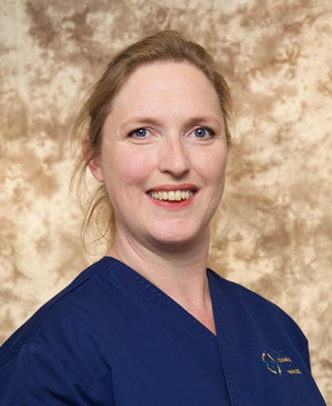

DR MABS CHOWDHURY

Dr Mabs Chowdhury MBChB, FRCP, PFHEA qualified from Leicester University in 1991 and trained on the Welsh Dermatology Programme. Since 2001, he is Consultant Dermatologist at the Welsh Institute of Dermatology, University Hospital of Wales, Cardiff and was appointed Honorary Senior Lecturer at Cardiff University in 2019.

He is President of the British Association of Dermatologists from July 2022-24. As Academic Vice-President, he chaired the Education Subcommittee to update the new pre-CCT trainee syllabus implemented in Aug 2021. He is joint Clinical Lead for Dermatology e-learning for Health to oversee 140 e-modules mapping to the new curriculum. He was previous Chair of the SCE Exam Board, Clinical Director in Cardiff and Welsh Training Programme Director for 10 years.

He has published 110 papers and is co-author of the undergraduate textbook Dermatology at a Glance and co-editor of BAD textbook Dermatology Training: the Essentials 2022. He has trained over 20 specialty registrars and supervised the first completed post-CCT cutaneous allergy fellow in the UK.

Learning Objective for Cutaneous allergy meeting:
- To update on new cutaneous allergens for patch testing
- To update on methacrylate allergy
- To update on inflammatory complications of permanent tattoos

DR STEFFEN SCHUBERT

Dr Steffen Schubert is Research Associate based at the Information Network of Departments of Dermatology, Institute at the University Medical Center Göttingen in Germany. His doctoral thesis (PhD) was on “Characterization of the multifunctional XPG protein during Nucleotide-excision-repair”.
He is a member of the European Society of Contact Dermatitis (ESCD) and the
European Society of Tattoo and Pigment Research (ESTP board member).

A selection of his publications are below:
Schubert S, Dirks M, Dickel H, Lang C, Geier J; IVDK. Allergens in permanent tattoo ink - first results of the Information Network of Departments of Dermatology (IVDK). J Dtsch Dermatol Ges. 2021; 19(9): 1337-1340; doi: 10.1111/ddg.14530
Schubert S, Aberer W Allergic Reactions to Pigments, Metals, and More? Body Art from the Allergist’s Point of View. In: C. De Cuyper, M. L. Pérez-Cotapos S (eds.), Dermatologic Complications with Body Art, Springer International Publishing AG, part of Springer Nature 2018, (7) 139-176.

Schubert S, Worm M, Dickel H, Wagner N, Brans R, Schröder-Kraft C, Bauer A, Koch A, Geier J; IVDK. Patch testing shellac in consecutive patients – data of the Information Network of Departments of Dermatology (IVDK) 2021. Contact Dermatitis 2023; 88(1): 77-80, doi: 10.1111/cod.14227

Schubert S, Lessmann H, Schnuch A, Uter W, Geier J; IVDK. Factors associated with p-phenylenediamine sensitization: data from the Information Network of Departments of Dermatology, 2008-2013. Contact Dermatitis 2018: 78: 199-207; doi: 10.1111/cod.12920.

DR NATALIE STONE BA (hons) Oxon, FRCP

Dr Natalie Stone has been a Dermatology Consultant at Aneurin Bevan University Healthboard since 2000.

She qualified from the Royal Free Hospital, London in 1992 and trained on the Oxford Dermatology rotation.

She represents Wales on the BSCA and was BSCA secretary from 2017-2022. She is the current chair of the Welsh Dermatology Forum and chair of the Welsh Dermatology Planned Care and Recovery Board.

She has published widely in the field of Allergic Contact Dermatitis and is co-author of the current allergic contact dermatitis chapter in the new edition of the Rook Book.

